

KELCO INDUSTRIES:
PROCESS FLOW DOCUMENT:
RECORD TO REPORT

Paapri Cloud Technologies
Login to Role: Controller

Company Information:

Navigation: Setup -> Company -> Company Information

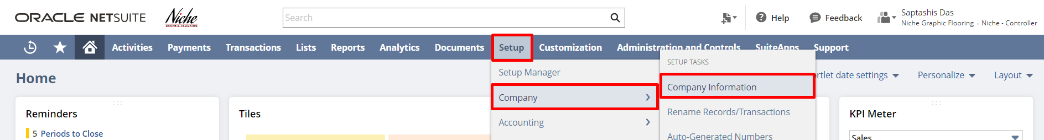

The Company Information page is where a Controller sets up company permission and can enter basic identifying information for an account like company name, company logo, company return email address, fax, company address, EIN, SSN, or TIN Number, etc.

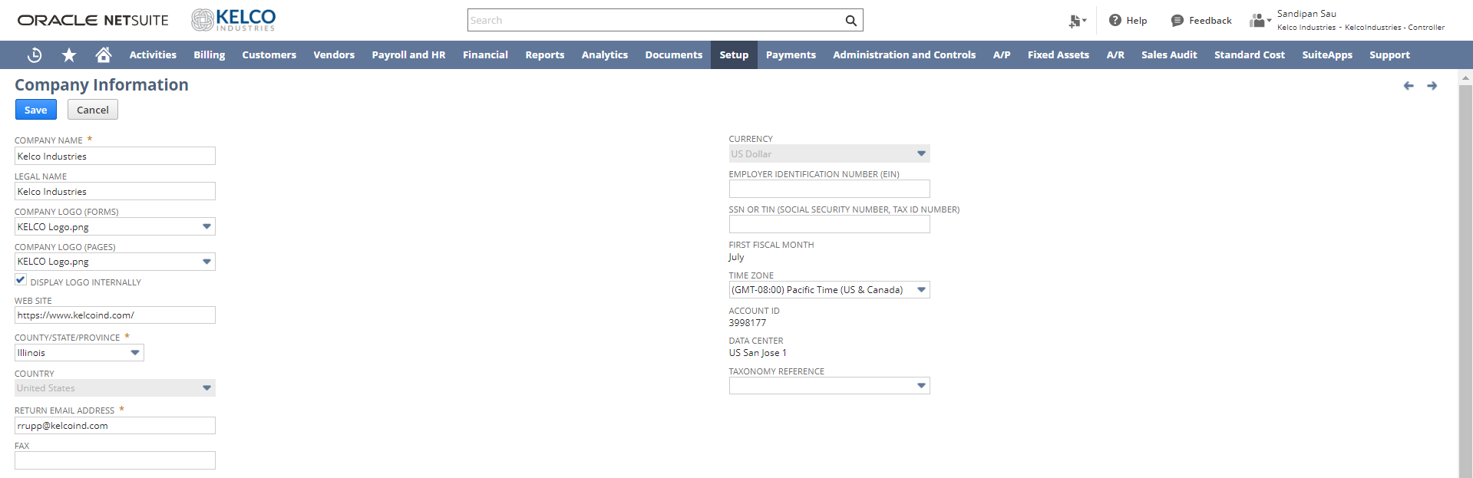

Note: The field “Return Email Address” is an important field since all the return requests happening in the system will be utilizing this email id. In the future if the company changes/updates the return email they have to update it over here also.

To add/edit a company address, click on the Edit button. A pop-up with all the address fields will open where the address can be entered.

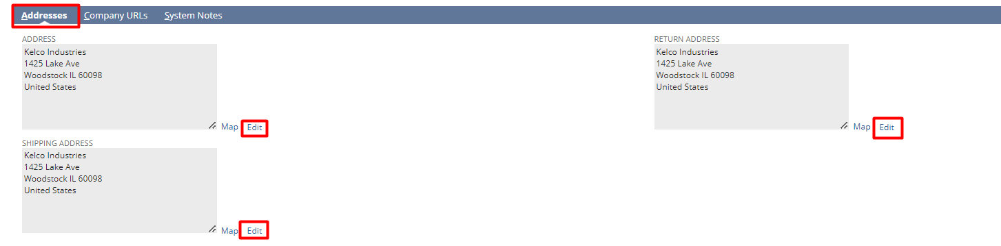

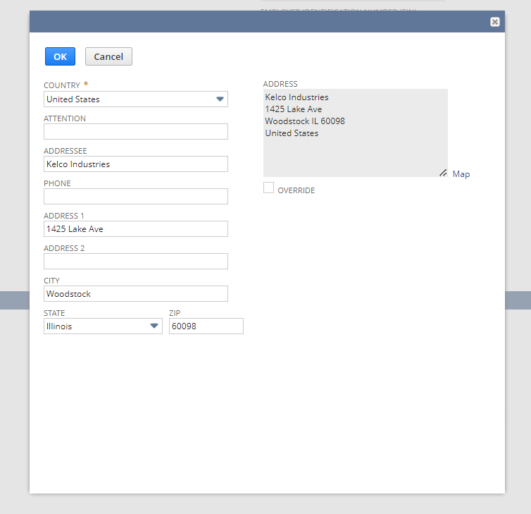

Rename Records/Transactions:

Navigation: Setup -> Company -> Rename Records/Transactions

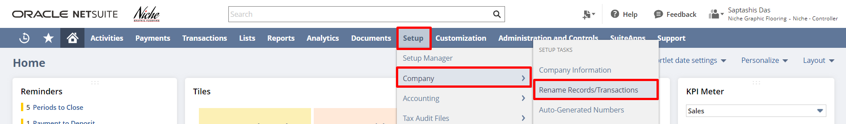

You can change the names of your records and transactions from NetSuite default names to names that fit the terminology of your company on Rename Records/Transactions page. On this page, you can also change the names of the account types used in NetSuite.

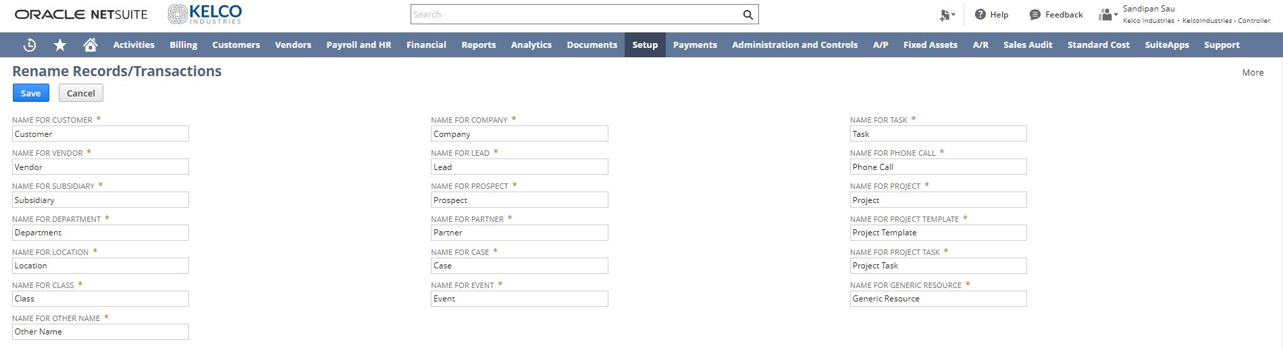

In the Rename Records/Transactions page body, you can change the names of standard NetSuite non-transactional record types.

On the Transaction Names subtab of the Rename Records/Transactions page, you can change the names and abbreviations of standard NetSuite transaction types.
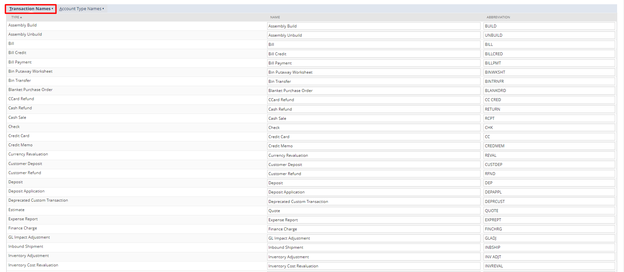

On the Account Type Names subtab of the Rename Records/Transactions page, you can change the names of standard NetSuite account types.

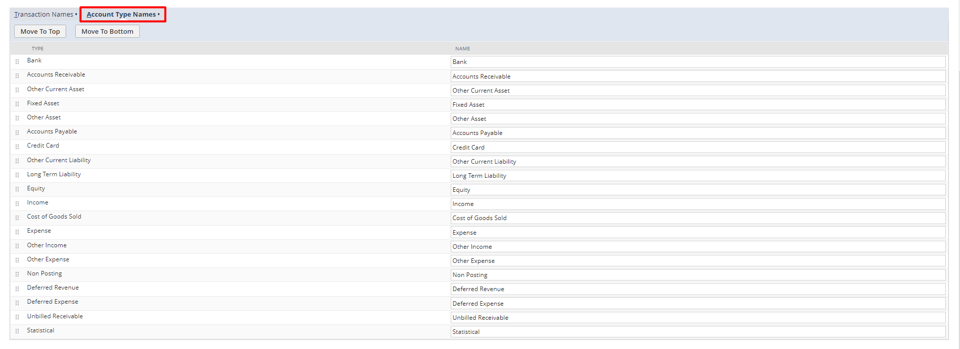

Auto-Generated Numbers:

Navigation: Setup -> Other Setup ->Auto-Generated Numbers.

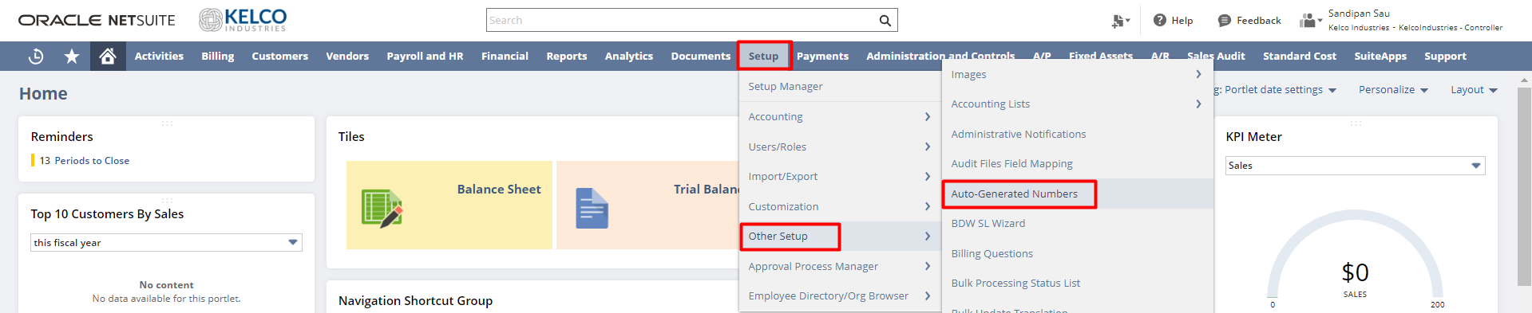
The Set-Up Auto-Generated Numbers page enables you to choose the record types that should be automatically numbered in the order in which they are created. On this page, you can also add prefixes and suffixes to auto-generated numbers. Prefixes and suffixes are useful in determining a record, transaction, or document’s type and estimated age at a glance

For example, you may choose to enable auto-generated numbering for the customer record type in your account and prefix the number with CUST. Each time you add a new customer record, the record number increases sequentially by one. When you view your customer list, you can quickly see that CUST0025 is a newer customer than CUST0004.

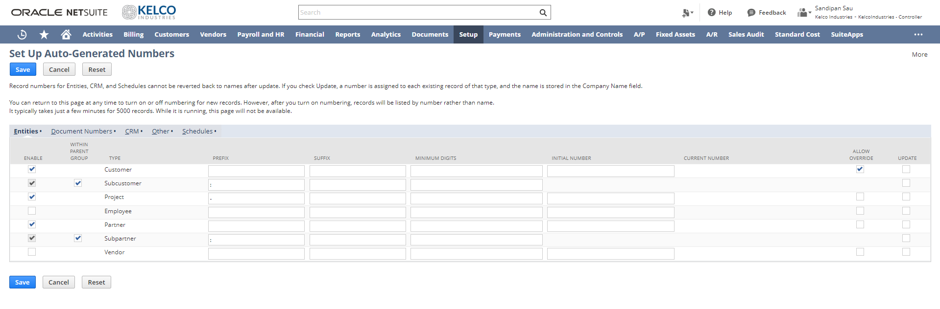

General Preference:

Navigation: Setup -> Other Setup -> General Preferences

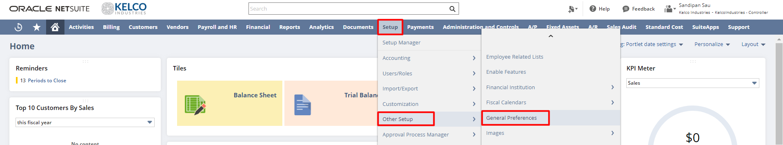

A controller or another user with the Set-Up Company permission can set company Preferences for how information is input and processed in NetSuite, on the General Preferences page. These Preferences apply to all users in the account.

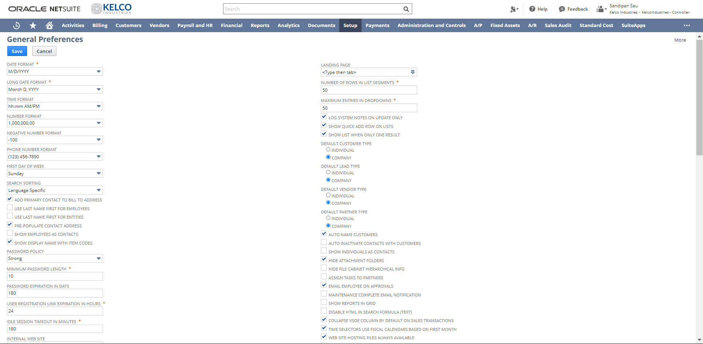

Terms:

Navigation: Setup -> Other Setup -> Accounting Lists

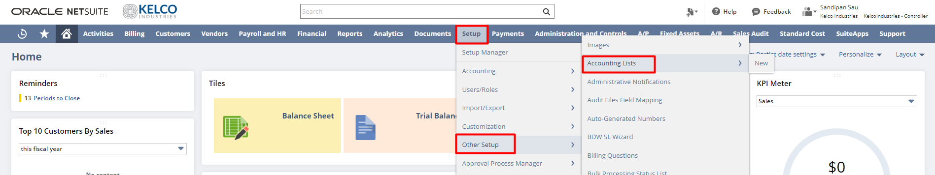

After going to this page, select Term from the dropdown of accounting lists, and the user can see all the terms present in the system.

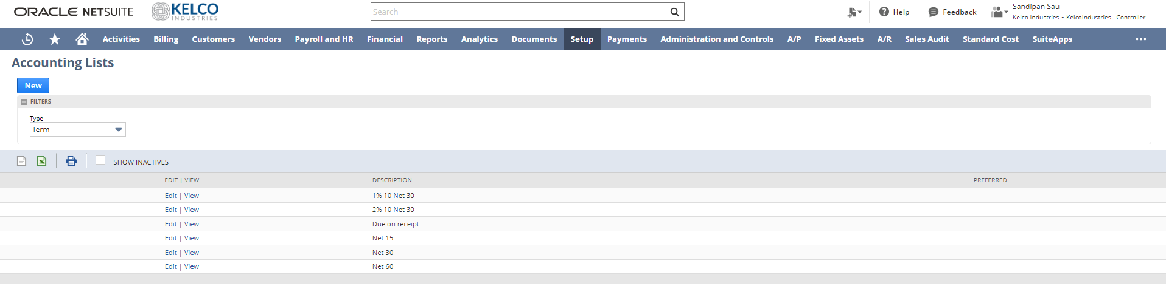
Accounting Preferences:

Navigation: Setup -> Accounting -> Accounting Preferences

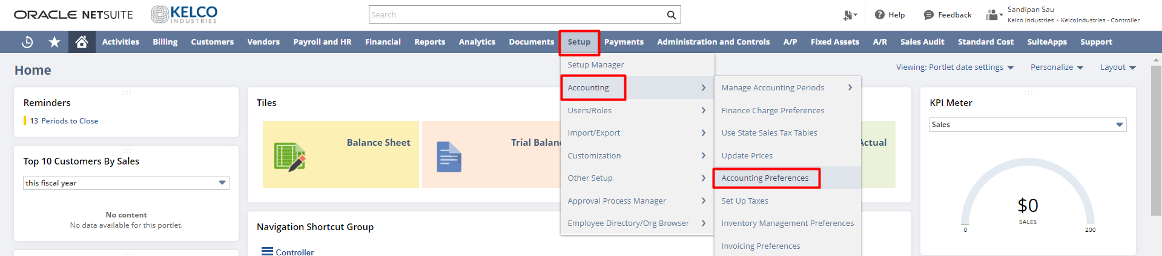

In the Accounting Preferences, we can make the changes for the Accounting-related requirements.

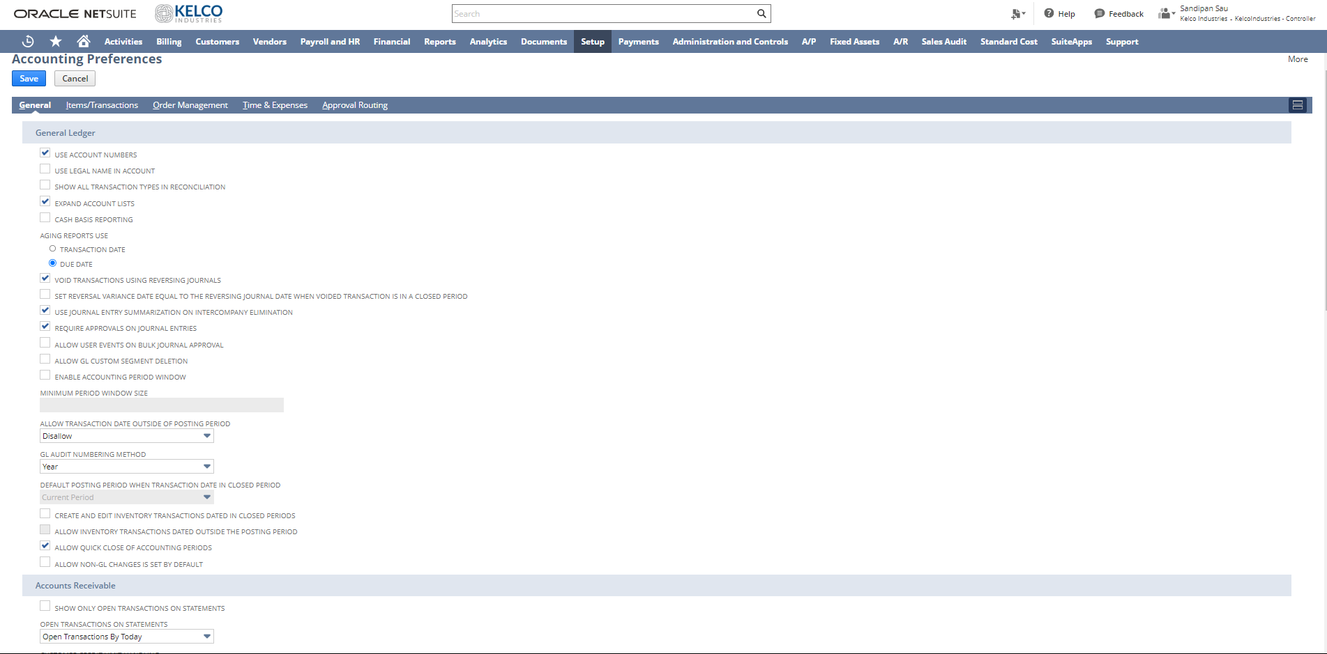

Set Preference/User-Specific Preference:

Navigation: Home Icon -> Set Preferences

This section of NetSuite Basics describes the preferences that are available to you as a NetSuite user.
The Set Preferences page displays options for most aspects of your NetSuite account. These preferences enable you to set up your NetSuite account to fit your needs. Your user preferences are constrained by the features enabled for your account, company account-level preferences, and the role-based dashboards that are set up by the controller.

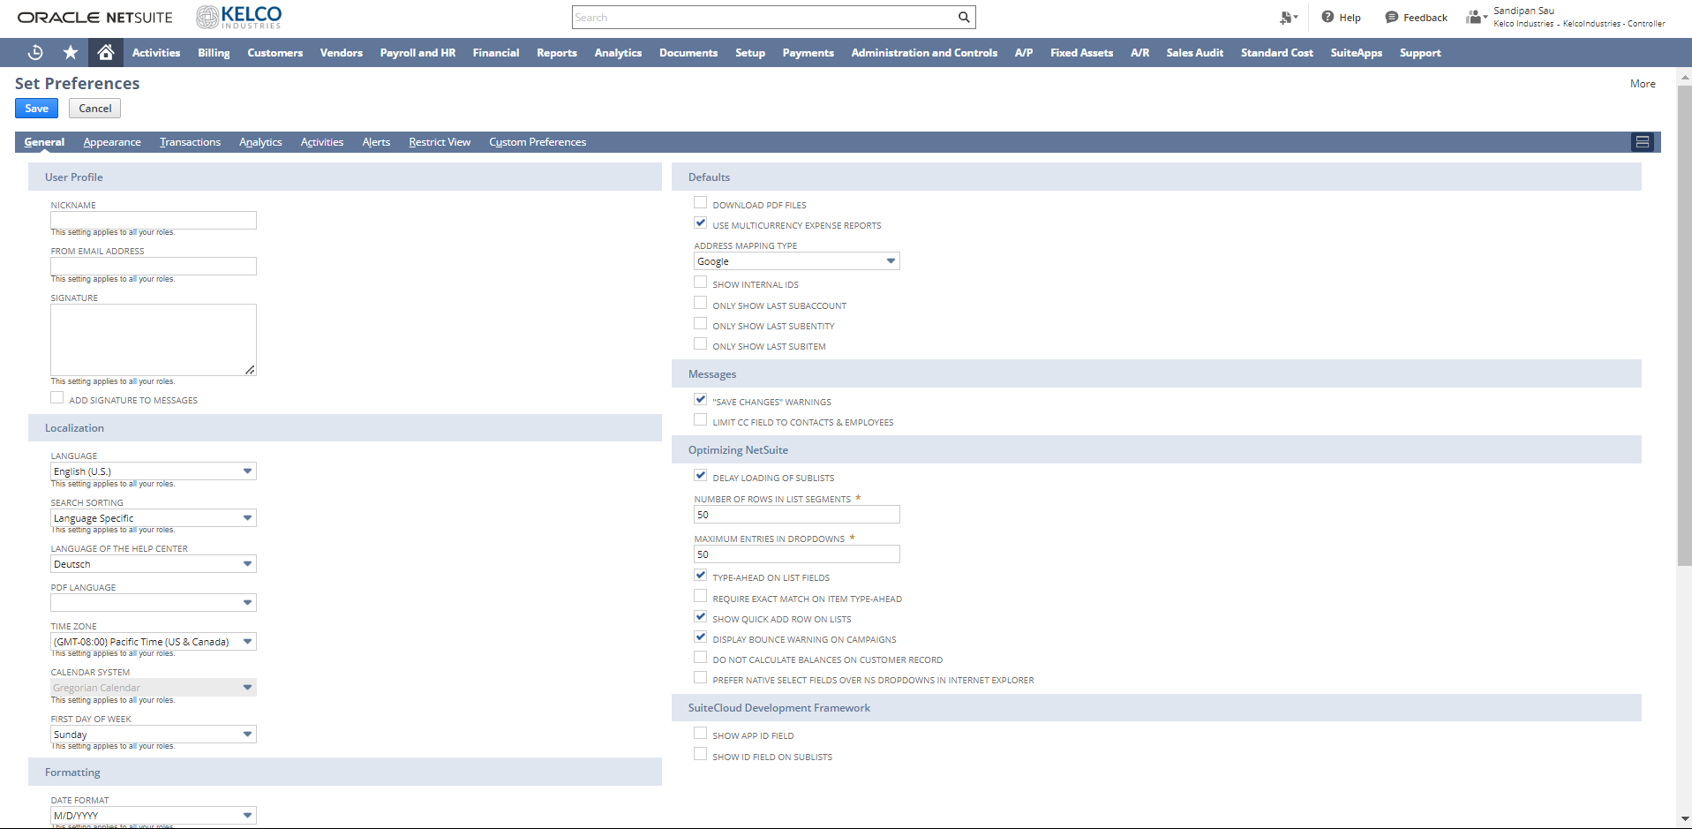

Setup Accounting Periods:

Navigation: Setup -> Accounting -> Manage Accounting Periods

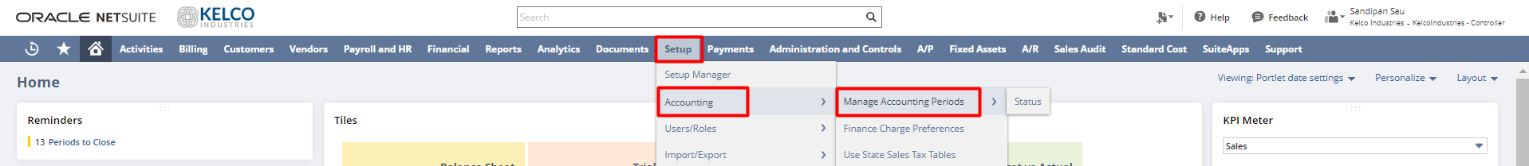

You have the option of setting up a single accounting period at a time or generating all periods for a full year using the Set-Up Full Year button. The best practice recommendation is to use Set Up Full Year to generate all periods and to roll up the hierarchy for a full year. You must have at least the Edit level of the Manage Accounting Periods permission to set up accounting periods.

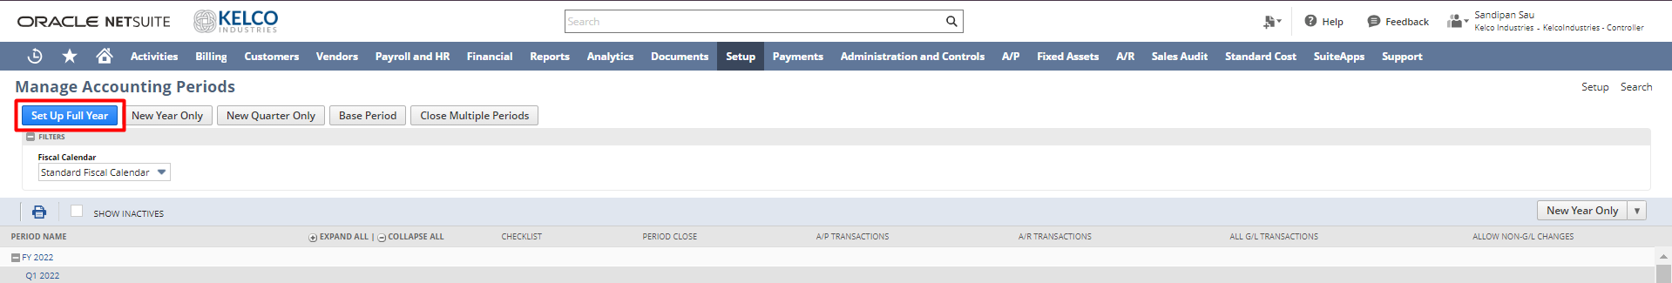

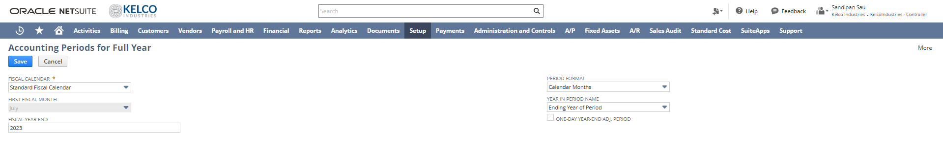

Accounting Period Close:

Navigation: Setup -> Accounting -> Manage Accounting Periods


Closing an accounting period means changing its status from Open to Closed. The status of Closed indicates that posting transactions for the period has been completed. This status prevents posting to the general ledger for any dates included in the period, by anyone. Closing a period should be a final step, after a process of accounts review and reconciliation to ensure correctness and balance.

From the Period Close Checklist, you can close accounting periods.

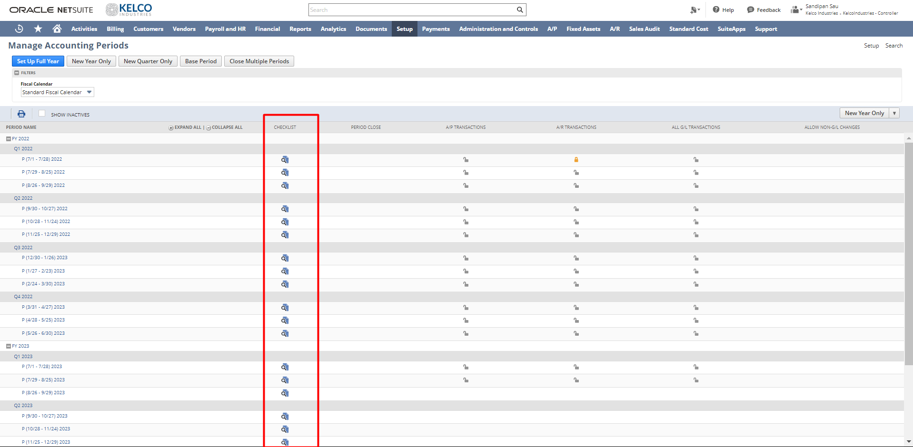

After clicking on the period close checklist, you will find a new window that will show you the Period Close checklist. From this checklist, you can complete the required tasks in sequence and then close the period.

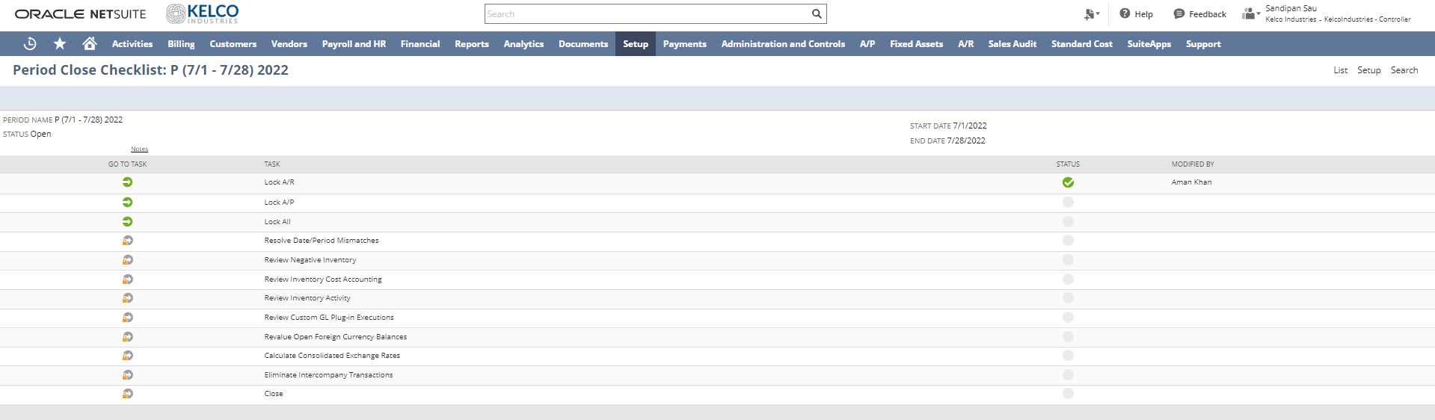

From individual tasks, you can close a period subsidiary-wise.

Segmentation:

Classes, Departments, and Locations are 3 ways to divide virtually all the information in NetSuite.

1. Classes:
Navigation: Setup -> Company -> Classes -> New
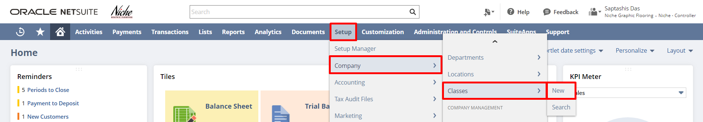

Classes are categories that you can create to track records such as financials, transactions, and employees. For example, you own a janitorial service and you want to track income and expenses separately for household and commercial accounts. You set up a class for each account type and track the financial performance of each class over any period.

You can enter a class name, select a subsidiary as well as can select a parent class for a subclass.

Please note that using the ‘Include Children’ check box you can associate the class with all the subsidiaries associated with each subsidiary selected in the subsidiary field.
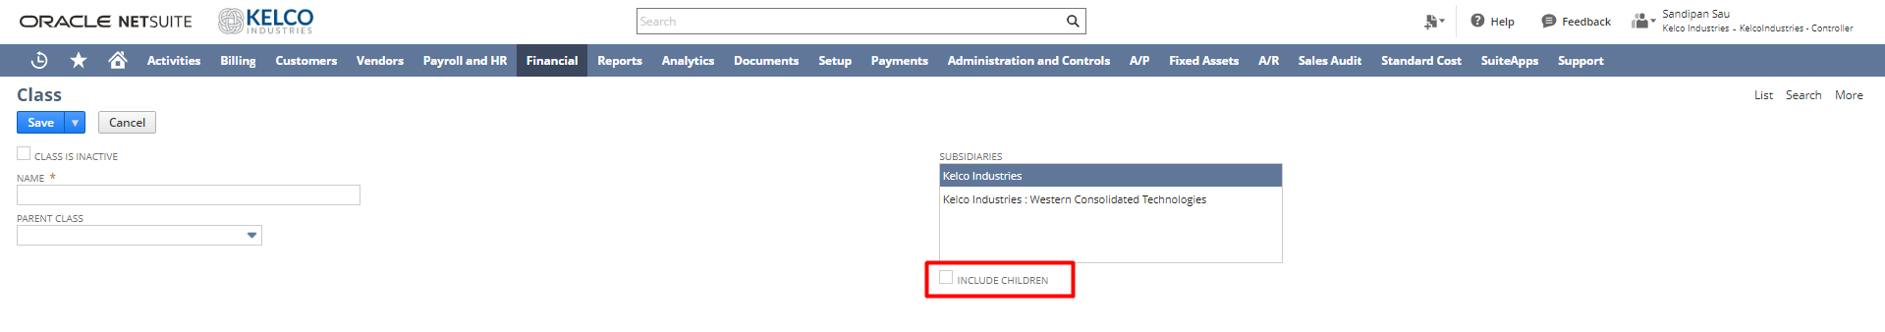
2. Departments:

Navigation: Setup -> Company -> Departments-> New

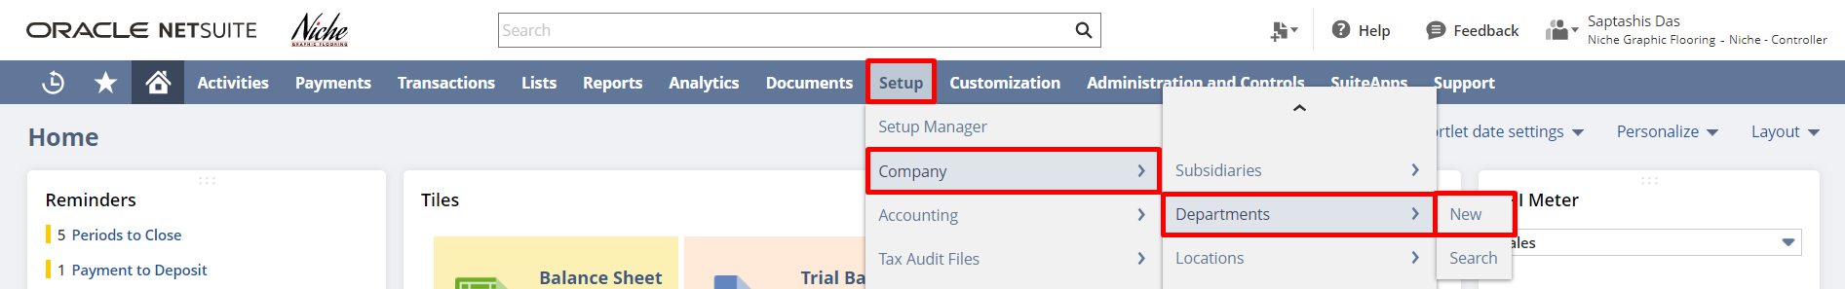

Departments are categories that you can create to separate and track records such as financials, transactions, and employees. For example, you can create a department for each team of employees dedicated to a certain area of business, and then track the income and expenses of each department over any period.

You can enter a department name, select a subsidiary as well as can select a parent department for a sub-department.

Please note that using the ‘Include Children’ check box you can associate the department with all the subsidiaries associated with each subsidiary selected in the subsidiary field.

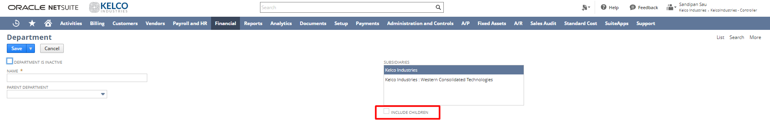
3. Locations:

Navigation: Setup -> Company -> Locations-> New

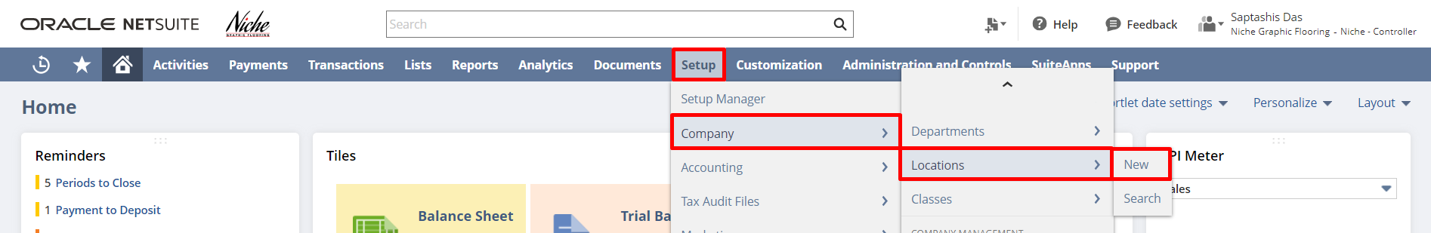

You can create a location record for each of your company’s locations. Then you can track employees and transactions by location. You can enter a location name, select a subsidiary, select location type as well as can select a parent location for a sub-location. Using the ‘Make Inventory Available’ check box you can make on-hand inventory stored at the location available to orders. Using the ‘Use Bins’ check box you can track inventory bins at a particular location.

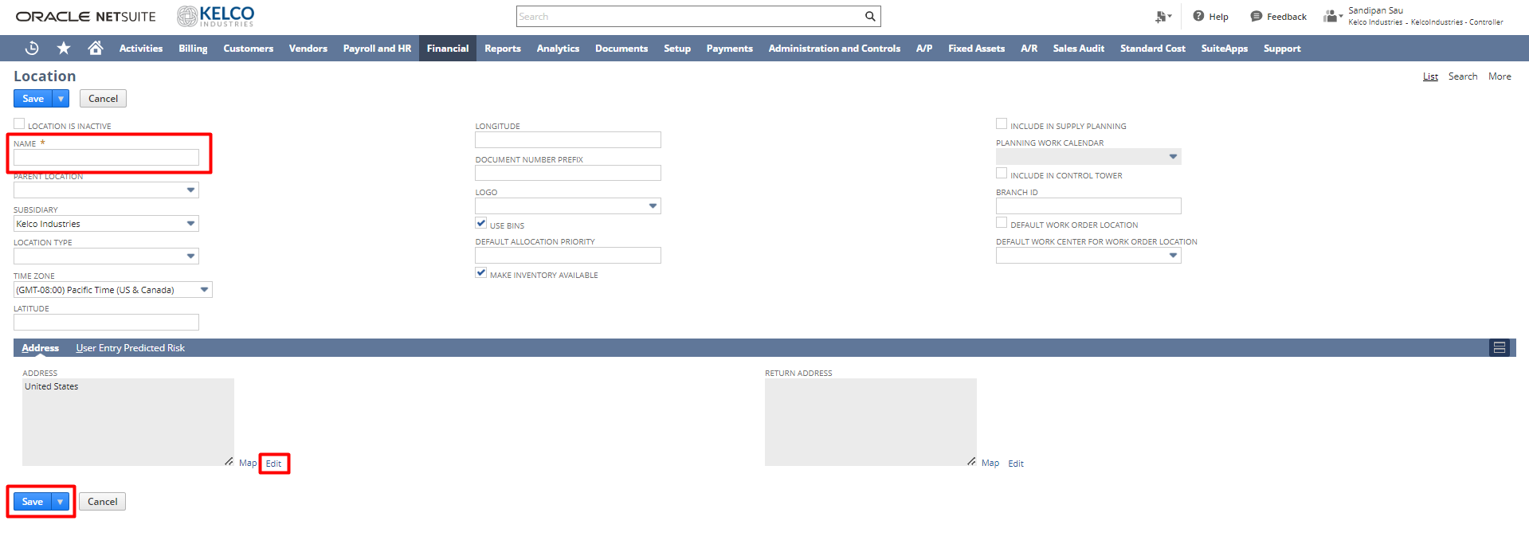

Nexus:

Navigation: Setup -> Other Setup -> Nexuses -> New

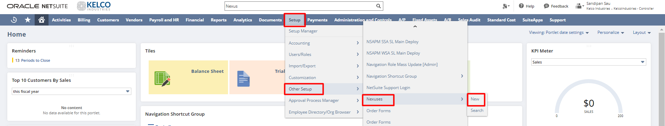

Nexus is a tax jurisdiction. Each subsidiary is associated with at least one nexus. The first nexus is automatically assigned to a subsidiary based on the company entered for the subsidiary’s address. A subsidiary can have more than one nexus. A nexus and its related tax items can be shared by multiple subsidiaries.
To create a nexus, enter the country name that you are making this nexus for, enter the description for this record, and select the state/province/country that you are making this nexus.

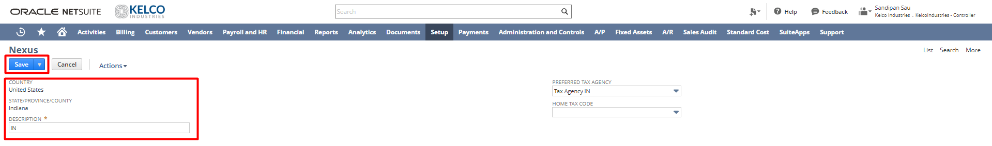

Tax Types:

Navigation: Setup -> Other Setup -> Tax Types -> New

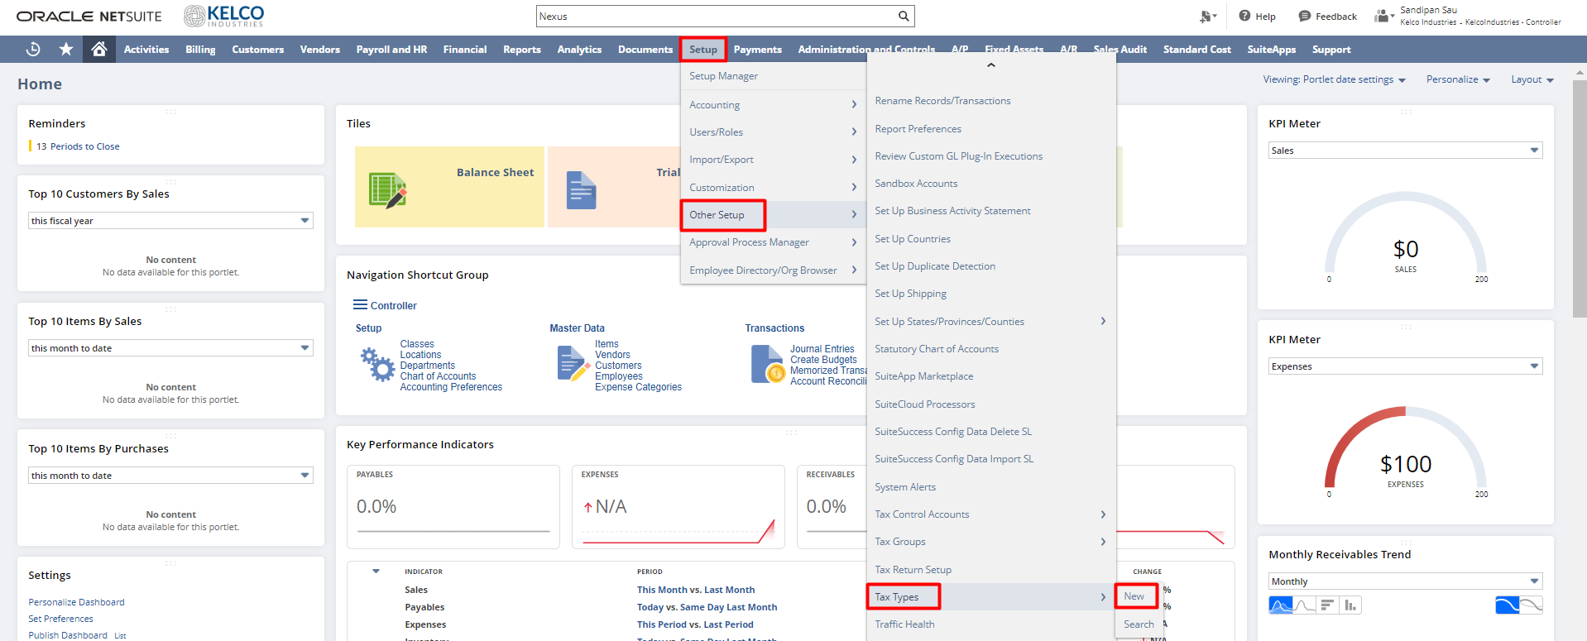

A tax type determines where the tax paid or collected is tracked on the balance sheet. In NetSuite, are either already set up by default, or set up for you by professional services. When
you add a subsidiary in a new country the tax type for that country becomes available in the system automatically. However, a controller can create a new tax type if necessary.

To create a new tax type, enter a name or abbreviation for this tax type, enter a description of this tax type, and from the Accounts tab, select the Liability/Sales Tax Account and Asset/Purchase Tax Account.

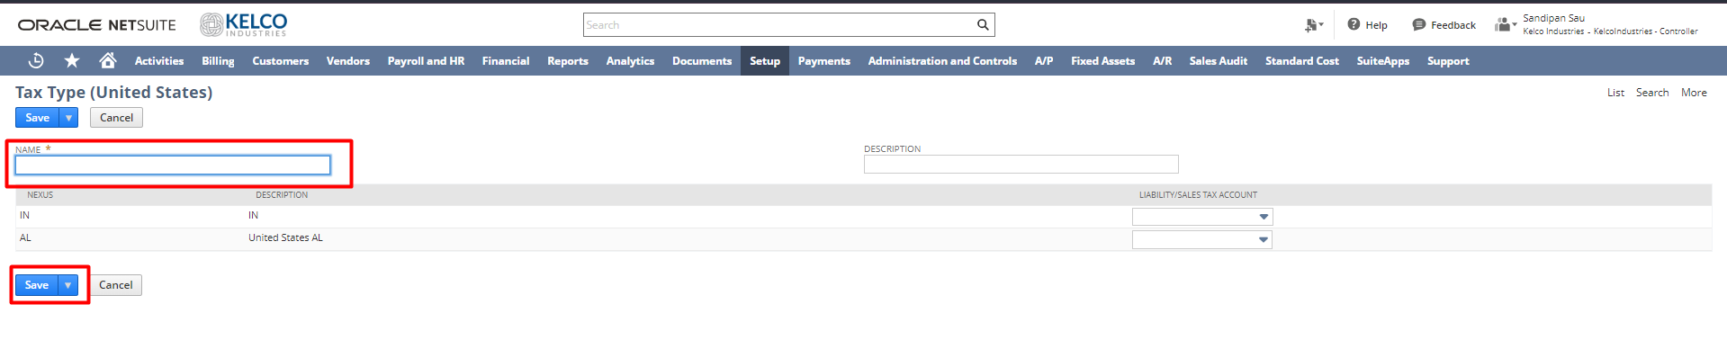

Tax Code : ( LEFT FRO HERE )

Navigation: Setup -> Accounting -> Tax Codes -> New

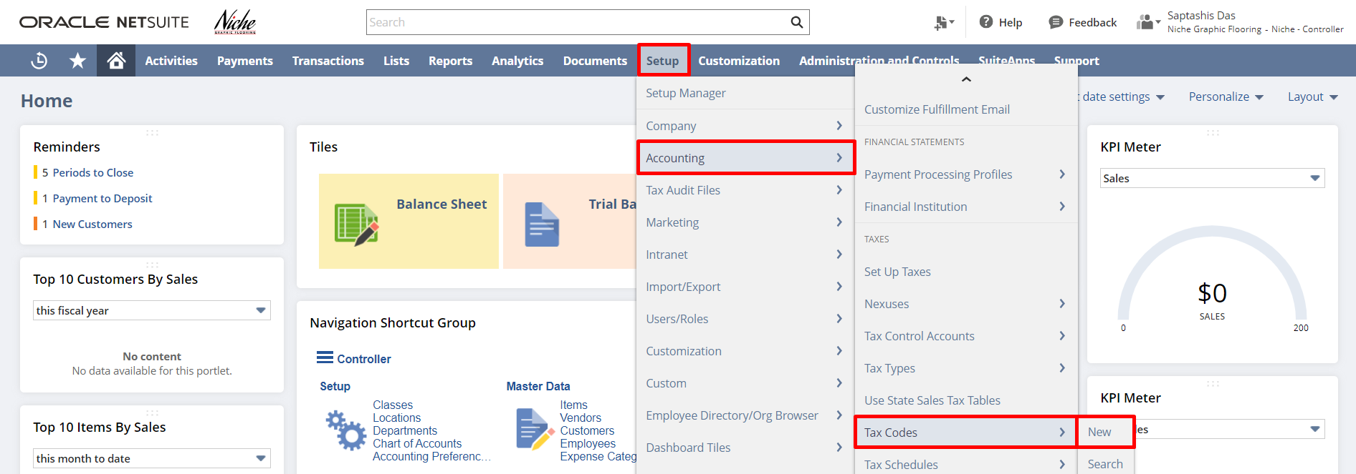

Tax codes determine how much tax your company must bill and pay on each transaction line item. In the UK Edition, NetSuite provides default tax codes. You can edit the properties in the tax codes, rename the tax codes, or create new tax codes.

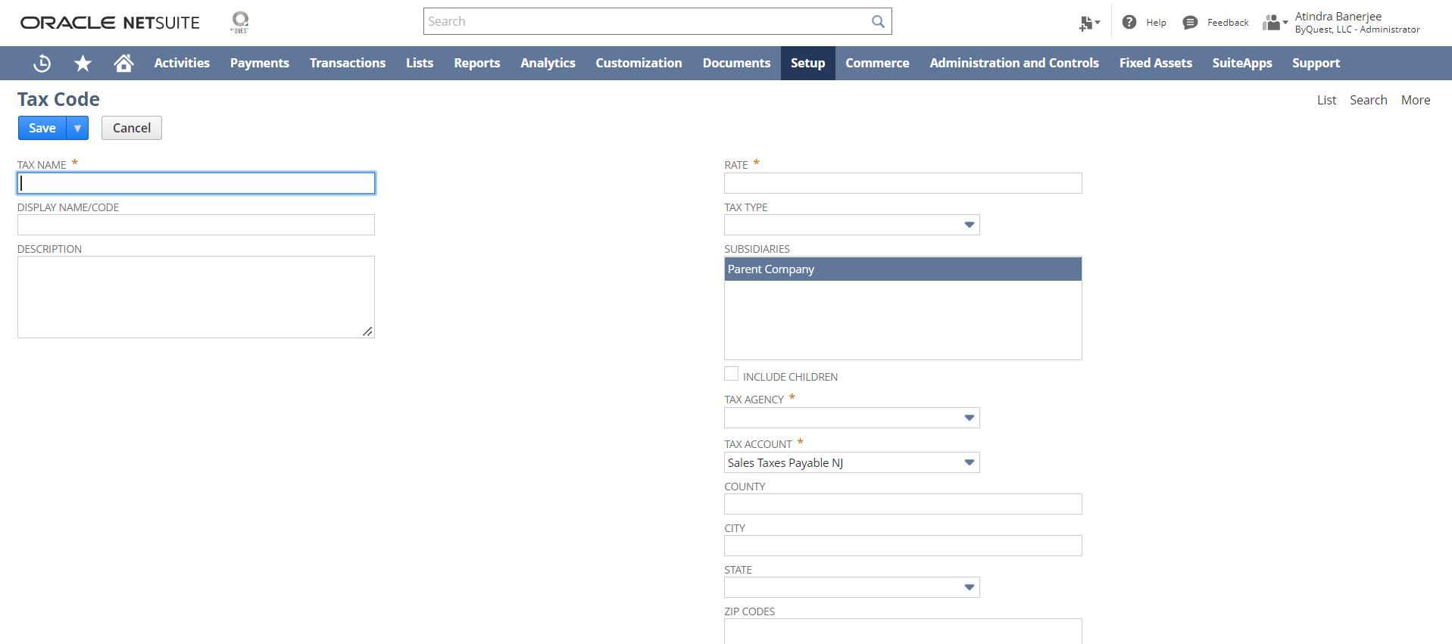

When you create sales or purchase transactions, you can apply this tax code to line items. To create a Tax code, enter the Name or an Abbreviation, Description, and Rate, choose tax property like EC Code, applies to service items, Reverse Charge Code, Notional Rate Derived from, Export, Exempt, Default Code, Exclude from VAT Reports, etc. You can also select the Tax Agency that this tax is paid to, select the Tax Type for this tax code, and select the types of transactions from the Available On field that this tax code can be applied.

Tax Schedule:

Navigation: Setup -> Accounting -> Tax Schedules - > New

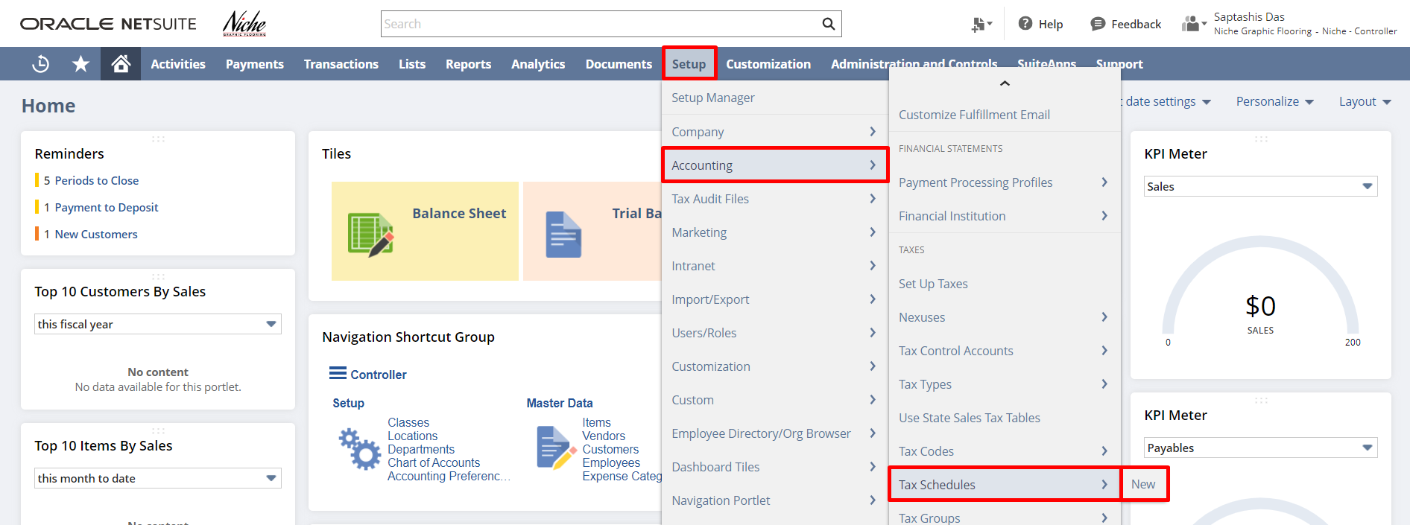

The tax schedule determines how NetSuite calculates taxes for items in each nexus. The Tax Schedule field on the item record is located in the accounting subtab, under Tax/Traffic information. The tax treatment for an item is determined by the tax code assigned to it.
To create a new Tax Schedule, enter the product field enter the name of the tax schedule that you want to associate with a product or item., the description and select the sales and purchase tax codes to be used.

Chart of Accounts:

Navigation: Lists -> Accounting -> Chart Of Accounts -> New

One of the first tasks you must complete before you can begin managing the account is to set up a chart of accounts. Your chat of accounts provides a set of destinations for posting transactions and categorizing transactions for tracking and reporting purposes.

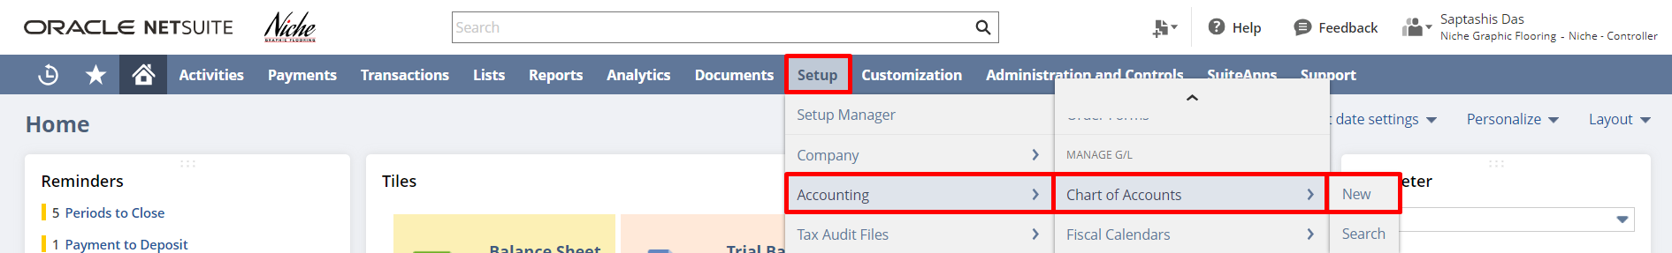

You can enter the account name and number, and select account type as well as a subsidiary. Using the ‘Include Children’ check box you can share the account with all the sub-subsidiaries associated with each subsidiary selected in the subsidiary field.

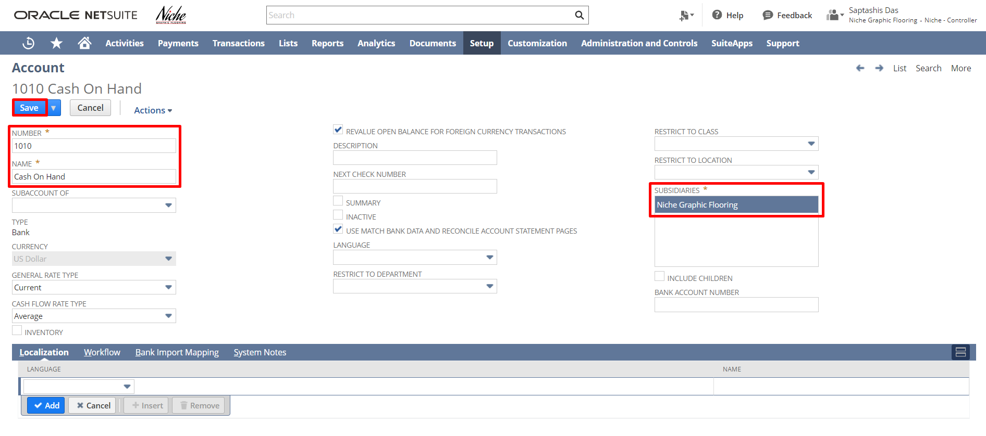

Journal Entries:

Navigation: Transactions -> Financial -> Make Journal Entries

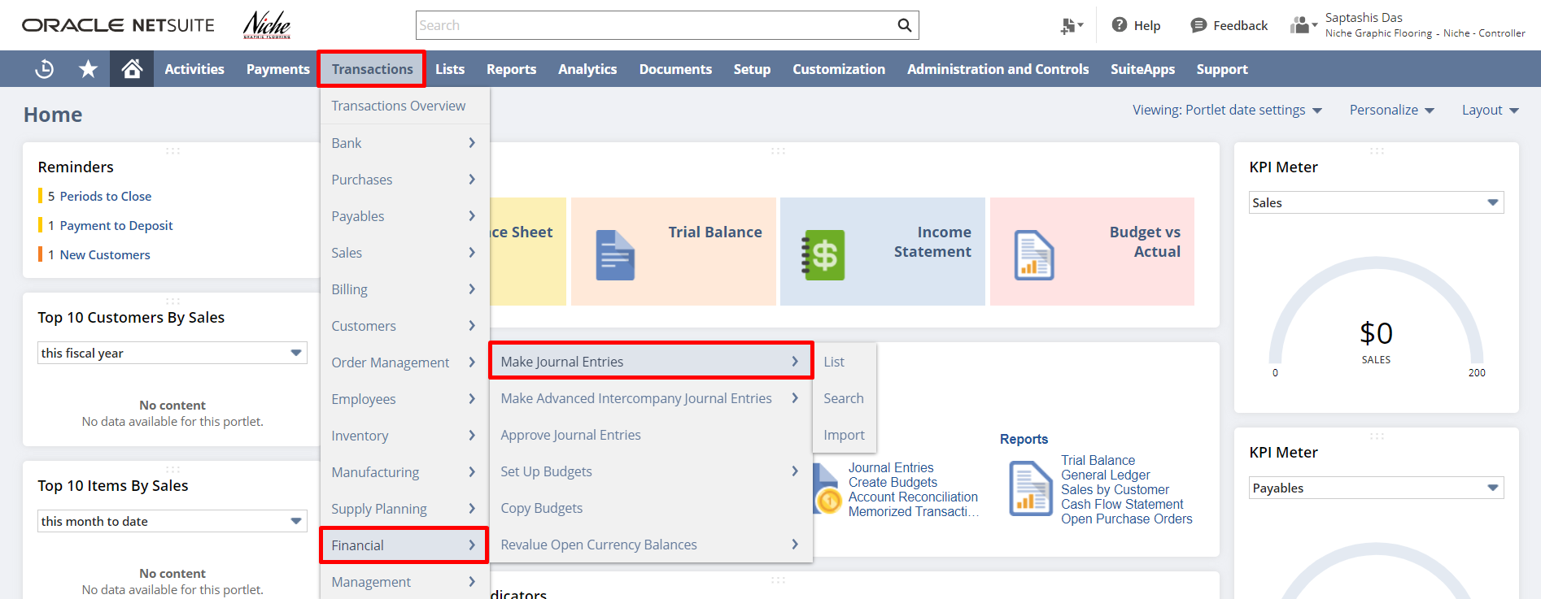

Use journal entries to adjust balances in your general ledger account without entering a posting transaction. Journal entry transactions are not posted until they are approved. A journal entry is posted in a period to which the journal entry approver has access. Until the journal entry is approved, NetSuite tentatively displays the posting period based on the transaction date, or, if this period is locked/closed, the first open period.

From the lines, subtab select the ledger account to be affected by this journal entry & enter the
Debit or Credit amount for each line.

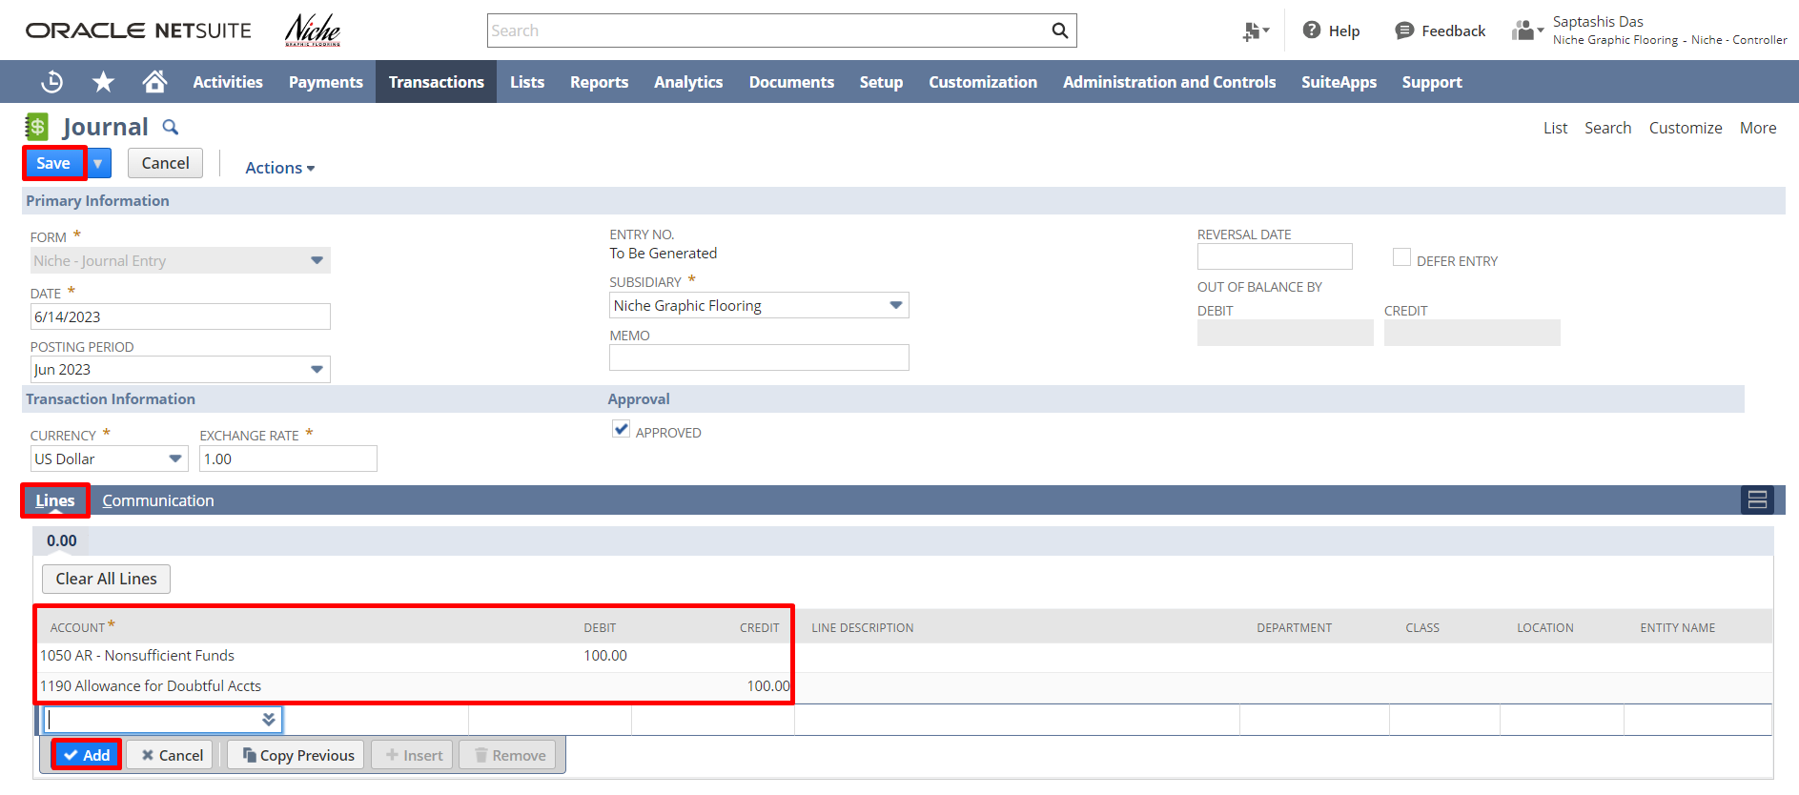

Budget:

Navigation: Transactions -> Financial -> Set Up Budgets

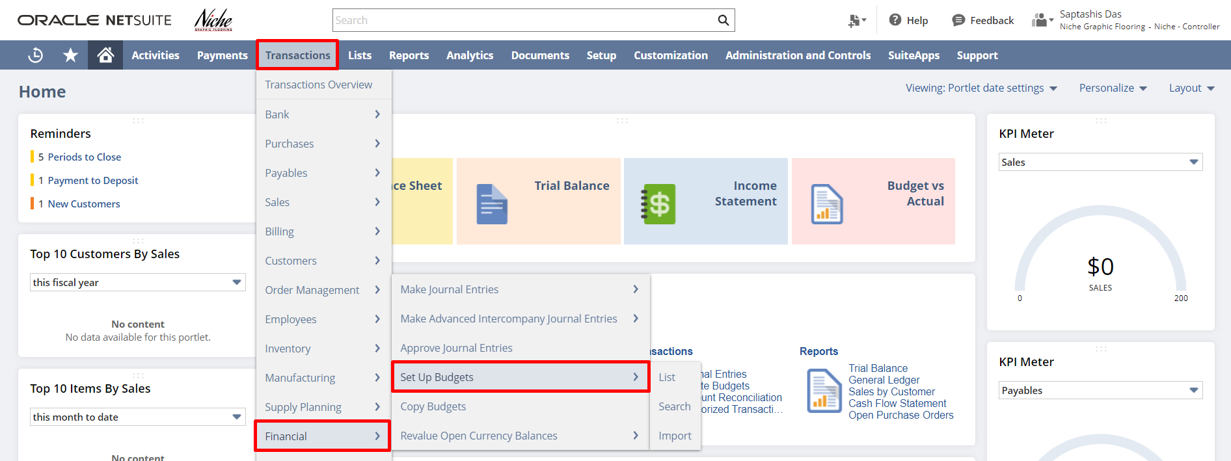

Each budget in NetSuite covers a fiscal year, for which you can enter an amount, per account, for each period. In NetSuite One World, budgets are specific to a subsidiary and fiscal year.

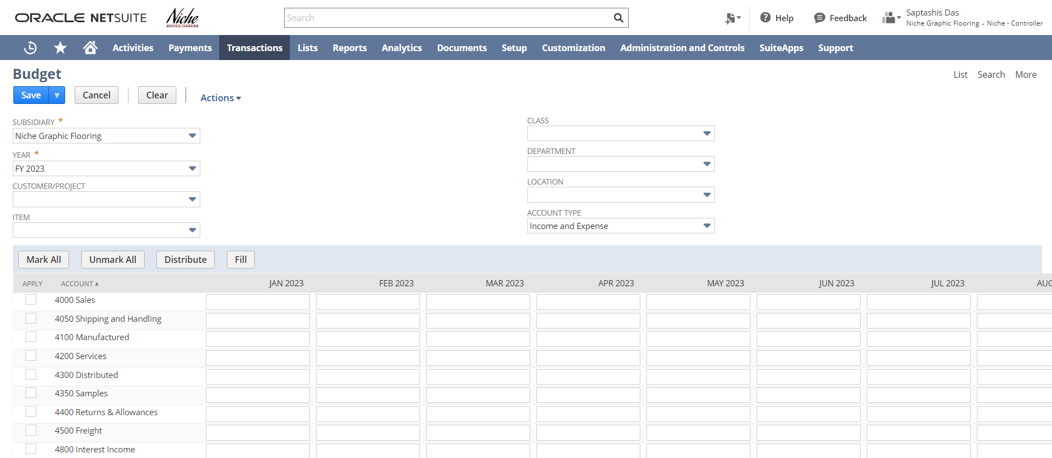

Write Checks:

Navigation: Transactions -> Bank -> Write Checks

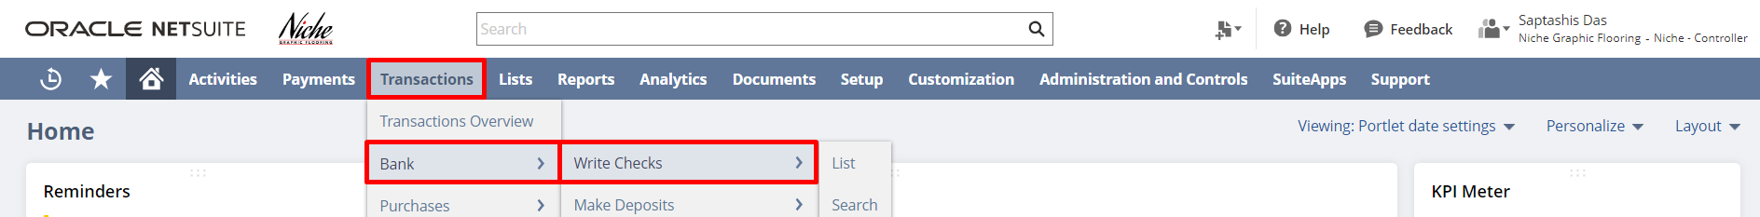

To create a new write check record, select a Payee, an Account that will be impacted. Enter the Date and the payment amount in the Amount field. Scroll down to the Items/Expenses sub list, select an
Item or an Expense and enter the Rate/Amount.
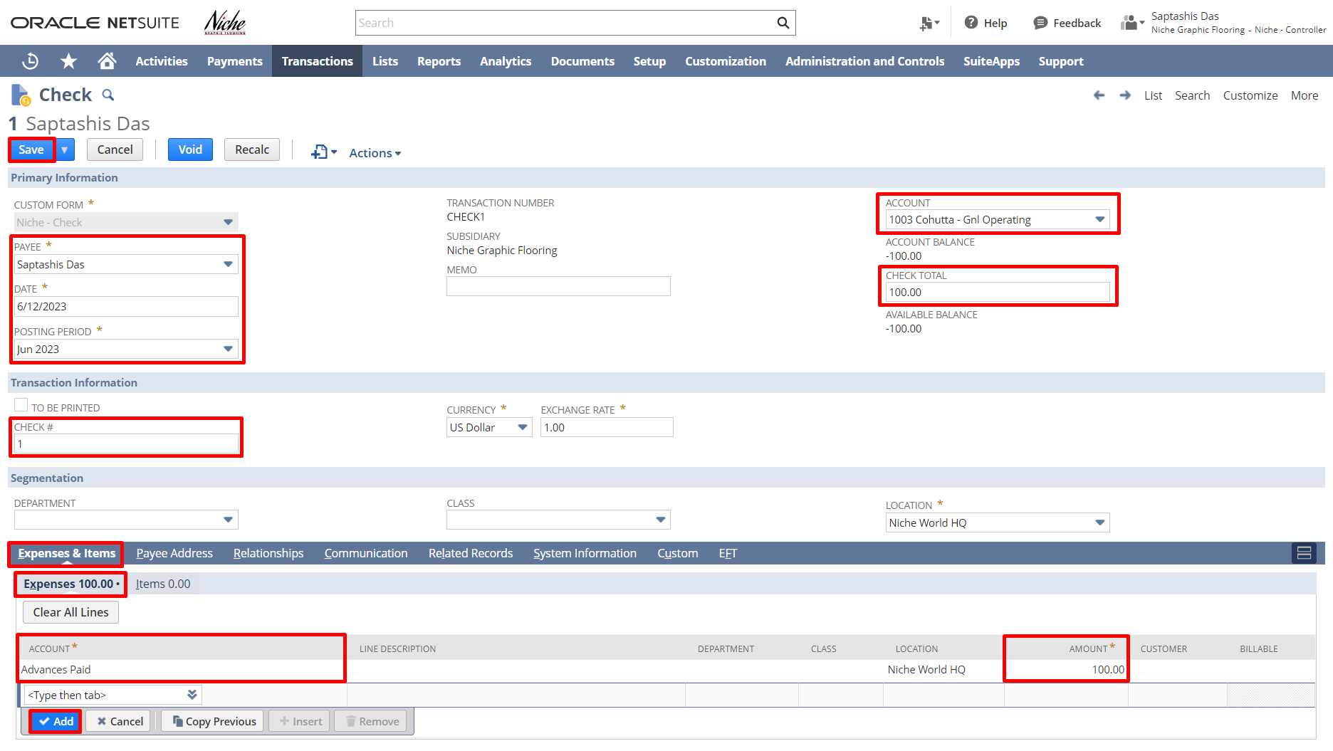
Make Deposit:

Navigation: Transactions -> Bank -> Make Deposits.

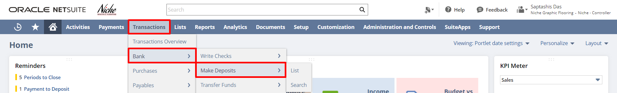

To make a new bank deposit record select an Account, and enter a Date. From the Deposits, subtab enters an Amount and Account in the Other Deposits sub-list.

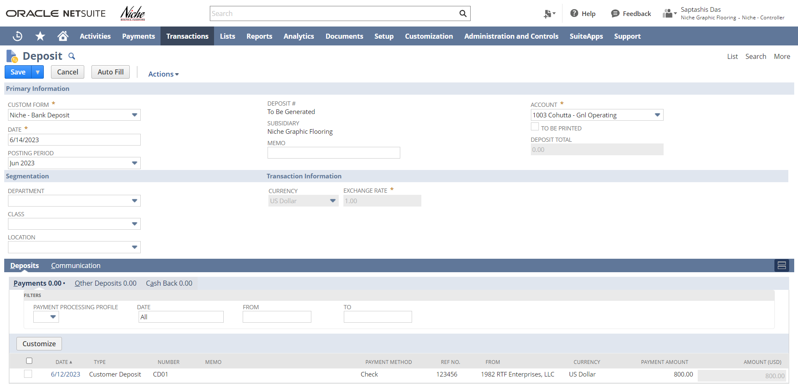

Reconcile Bank Statement:

Navigation: Transactions -> Bank -> Reconcile Bank Statement.

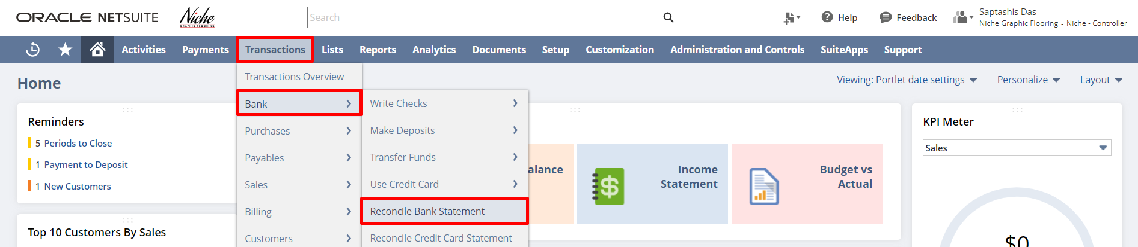

To reconcile a Bank Statement, select the bank account you are reconciling. The selected bank account determines the default subsidiary and currency. This filters the open transactions at the line level. Check the reconcile checkbox for the Transactions you want to reconcile. The Last Reconciled Balance provides the balance of this account from the last time you reconciled your bank statement.

In the Start Date field, enter the beginning of the reconciliation period. Unreconciled transactions before this date do not display on the subtabs. In the Ending Statement Balance field, enter the closing balance on the statement. The Reconciled This Statement and Difference fields update as you check the reconcile box next to transactions. The Difference field displays the amount that you must reconcile (when the difference is zero, reconciliation is complete). NetSuite calculates the Difference field amount by subtracting the combined amounts of the Last Reconciled Balance and Reconciled This Statement from the Ending Statement Balance.

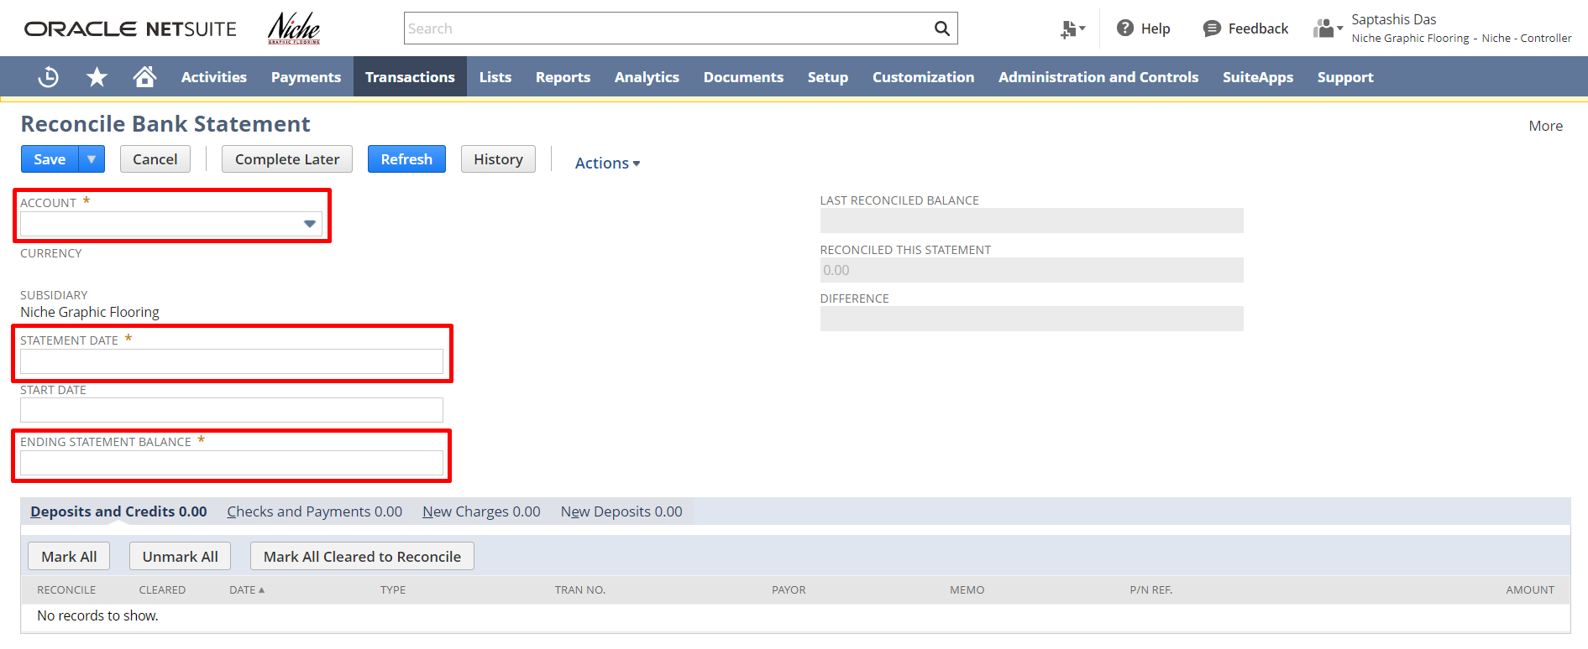

Currency:

Navigation: Lists -> Accounting -> Currencies -> New.

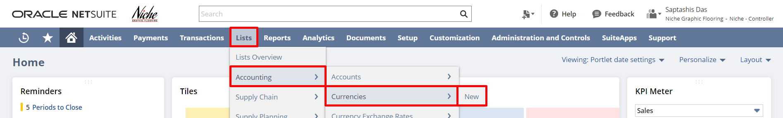

The Format Sample field displays the default currency format for the currency of the Default Locale.
In the Default Exchange Rate field, enter an exchange rate for this currency against the base currency of this company. To customize the format for this currency, check the Override Currency Format.

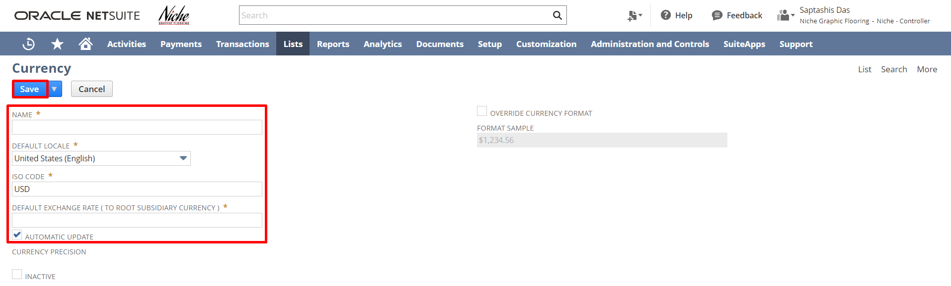

Signature: _______________________
Date: ______________________

Disclaimer:
Upon signing off on the document, you are confirming that the process has been set up per the SOW within NetSuite per your business’s needs. Any changes or modifications requested after sign-off will need to be a “change request” at an additional fee.

***PLEASE ensure that you have logged into NetSuite and tested the process before signing off on the setup. Paapri requires sign-off on this document before moving forward with any additional design meetings.

